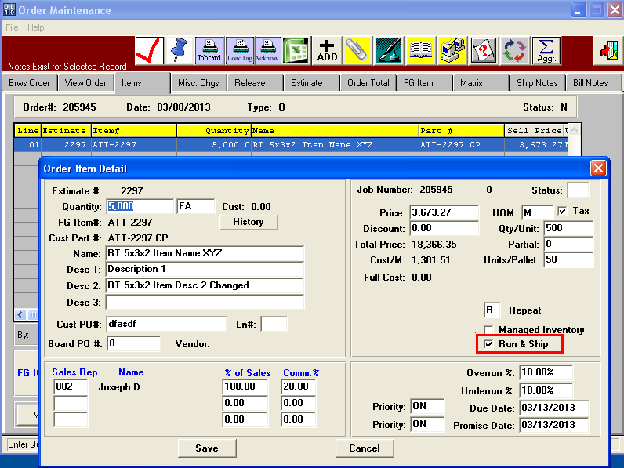

**RUN & SHIP Toggle Box Checked and N-K FGPost Integer Value = 1.**

Order browser shows the Quantity Produced which is the total for all Receipts for all Tags for that Job.   
Posting Finished Goods Receipts for Jobs will update Release Quantity for Job Overruns. This new logic will provide visibility to ship and invoice overruns that could become waste and lost revenue. Releases not processed will be overwritten with the Total Receipt Quantity. If the release has been processed, then a new release will be created for the Receipt Qty less (Order Qty-Actual Released). The Order Qty, Produced and Actual Release Qty quantities are displayed on the O-U-1 browser. The following must criteria must exist to update the Release Quantity or to create a new release:  
1) Job# exists for the Finished Goods Receipt and  
2) Total Receipt Qty for Job# exceeds Order Quantity (i.e. Overrun)   
3) O-U-1 Items Tab Run & Ship Toggle Box = YES

If 1, 2 and 3 are satisfied and Release has not been Processed (Status = "S", "I" or "L" or (A and not Printed) or (B and not Printed) then the Total Finished Goods Quantity will replace the Release Quantity on O-U-1 and O-T-1.

However,   
If Release has been Processed (Status is P, Z or C or (B and Printed) or (A and Printed)   
Then program will create a NEW Release on the O-U-1 Release Folder for Total Receipt Qty less Total Released Qty.

For Example:  
 Job Qty Produced is 14,500 and Order Qty was 12,000.   
The release has not been processed, then the Release Qty will be automatically changed to 14,500.   
This will also update the O-T-1 release if the release is not printed.   
If the O-T-1 release has been Printed or Bill of Lading Created and Printed for 12,000, then   
FG Posting will create a new release. Qty = Total Produced less Actual Release.   
Please note this logic will use Actual Shipped Quantity to determine overrun quantity not shipped.

As another example:  
A run and ship job order for 12,000 has a release created for 12,000.   
As production stacks 4000 per pallet, a truck driver may be waiting at the dock for the boxes.   
Once 3 pallets of 4000 are created, the skids are loaded on the truck and the driver leaves the dock. However, the machine then loads another unit of 2,500 boxes that are an overrun are received into inventory. At this point the system will create a new release for next day.

**Release Status Codes**

**S- Scheduled – Scheduled release based on date. Find in O-U-1-Release Folder.**

**L- Late – Late release. Current date past due date. Find in O-U-1-Release Folder**

**I- Invoice Now – Invoice release. Date past Last Ship date in O-U-1-Release Folder.**

**A- Actual – Actual release. Find in O-T-1 Actual release file.**

**P - Posted – Actual release Posted. Find in O-S-1 bill of lading file.**

**B- Backorder - Bill of Lading Posted. Find partial release in O-T-1.**

**Z- Completed - Bill of Lading Posted. Find in O-B-1 invoice file or invoice posted.**

**C- Invoiced - Invoice Posted . Must find in inquiries or Invoiced Releases.**